The usability testing on initial user interface design of Nakhon Si Thammarat National Museum Web Site

Asst.Prof.Dr. Suthanya Doung-in¹ and Dr. Satjaree Sirichai²

School of Informatics, Walailak University
222 Thaiburi, Amphur Thasala, Nakhon Si Thammrat, Thailand
dsuthany@g-mail.wu.ac.th¹, ssatjare@wu.ac.th²

Abstract

This research is to evaluate the initial user interface design of Nakhon Si Thammarat National Museum Web Site by using usability testing. The initial interface is developed by applying social information access features for users to exchange ideas and knowledge in a virtual commnity. The quantitative and qualitative data are collected by using questionnaire and interview etc. The results found that the interface provides well organization and some of social features are useful. Also, the participants’ recommendations are included.

Keywords: usability testing, social information feature;
Nakhon Si Thammarat National Museum web site, user interface design, virtual commnuty.

I. Introduction

The Word Wide Web (WWW) and advances in digitized technology have rapidly increased the amount of accessible information. Users may have difficulty in dealing with the amount of information and feel overwhelmed in trying to discover the desired information. Sometimes a user is incapable of identifying exact words or phrases to find relevant information or users may not explicitly state their needs in queries, especially when the user does not have sufficient knowledge about the subject matter [1].
In case of finding information in museum web site, users may need to have guidance of other people as well. Providing search and browsing information in museum web site are not enough for completing complicated tasks. The museum web site should take into account communication and collaboration facilities to support users for task accomplishment [2].
Following M. S. Ackerman [3] , social interaction is essential in providing mechanisms for seeking information. The existing user interfaces of museum web site require social tools to support interaction and social exchange between users and allow them to capture, structure and share knowledge [4]. We believe that social features and social information can be useful and reduces users’ effort to find relevant information to their tasks. Furthermore, users would like to have more enjoyable and social features to support them [5]. With respect to the benefits of social approaches, we decided to focus our work on museum web interfaces for supporting access and knowledge creation among individuals rather than isolation from each other. We believe that providing the social information access features in museum web site seems to be a good way that is useful for users to accomplish the task.

II. Related Works

2.1. Nakhon Si Thammarat National Museum

Nakhon Si Thammarat National Museum were funded by govenment for the digitized historical materials of Thai cultural heritage. At present, Nakhon Si Thammarat National Museum still provides services focusing on lifelong learning for various users that are students, teachers, researchers and individuals interested in history. The digital collection of Nakhon Si Thammarat National Museum comprises of about 1,330 digitized items. All are images. The collection are organized into four broad categories: (1) objectives of use, such as household items, agriculture tools, banknotes etc.; (2) types of material used such as wood, bronze etc.; (3) locations or sources, such as Thailand, China, India etc. and (4) duration of time or era, such as Prehistorical period, Ratanakosin Era etc.

2.2. Social information access features

Searching and browsing, as basic functions are often not adequate for solving complex tasks. In this situation, collaborative work and exchanging knowledge are relatively important to accomplish such a task.
P. Hansen, A. M. Pejtersen, and H. Albrechtsen [2] stated that the system should provide tools for facilitating communication and sharing knowledge among user community in order to support collaborative practices. C. Shah. [6] noted that collaborative activities can involve in several stages of seeking information: (1) during conducting queries; (2) while relevant documents encountered; and (3) when manipulating the outcome. Moreover, V. L. O'Day, and R. Jeffries [7] propose four levels in sharing results encountered within user community: sharing interesting items encountered; sharing advice and opinions; suggested queries; and organized result collection.
Social features may allow users to store and organize the information encountered into their space and control access to them in order to support sharing information among users, as mentioned above. Furthermore, it may provide users with shared facilities that can contribute their experience to others, such as reviews.
In this research, we designed the initial interface Nakhon Si Thammarat National Museum by integrating social information access features such as “Most popular searches”, “Five top viewed items,” and commenting in order to support users to share their ideas with others.

23. Usability testing
It is necessary to involve usability test in every phase of user interface design [8]. The aim of usability testing is to improve the system. Some faults in a program are revealed and fixed before releasing to real users [9]. Usability test was widely used in many evaluation museum and cultural heritage web site, for example, [10,11]. Usability problems were uncovered and further solutions were identified. Enhanced features can also be suggested to museum web site. To measure usability in this research, we opted two from four usability criteria from the usability evaluation model proposed by J. Jeng [12], namely effectiveness (the number of tasks completed) and user satisfaction (i.e. ease of use, interface characteristics, screen design, terminology used and visual attractive)

III. Research methodology
Evaluation of user interfaces
After implementing user interface Nakhon Si Thammarat National Museum web site, we conducted the usability study. The study was done with the interface to examine how participants interact with this interface, how easy it is to browse information in the collection, and overall of the system.
The usability sessions were conducted in June 2015. The testing was carried out in an office setting lecturer’s room at the School of Informatics, Walailak University.
The data collected during the study consists of quantitative study from the questionnaire and qualitative study from interview, note-taking the participants’ comments and actions during the test.
Participants & Apparatus
The usability test was conducted on a small set of participants (5 in total). J. Nielsen [13] have demonstrated that the usability test with 5 people provides a reliable results regarding a high probability (85%) to find problems. Five undergraduate students at the School of Informatics, Walailak university, who have experience in digital collections and museum. All students are studying in Digital Information Management Major. No participant had used the Nakhon Si Thammarat National Museum Web Site before doing this study.
Tasks
In order to study how participants interact with the system for finding information, participants were asked to perform six tasks: (1) What do you think this website is about?; (2) Who do you think is its target audience?; (3) At a first glance, do you think this web site could provide you with any information of your interest?; (4) Find the specific item “celadon”; (5) Find the most two favorite items in museum collection; and (6) Find the information about museum’s admission fee, directions to go there and open hours.), which applied from J. Woo [11] . A maximum time was set for all tasks in order to limit time spent on the study. This was 3 minutes for each task.

Procedure
A computer was provided for participants who were tested one participant at a time. The processes of this usability test were as follows:
• They were welcome and explained the overall aim of the study.
• They signed the consent form when they agree to participate in this study. They were asked to fill in a pre-test questionnaire to capture their profiles and experience of computer and museum background. Participants were rewarded 200 Thai baht per person for their participation after the study.
• They were asked to perform six tasks with no prior training.
• They were asked to fill in a post-test questionnaire to rate the ease of use, terminology used, visual attractive as well as assess overall of the system; and
• The participants were invited to interview to capture their perception of the interface about the best thing(s) of the site, the worst thing (s) of the site and the features from other museum web site would their like to include on new user interface Nakhon Si Thammarat National Museum web site.
The total time for one session was 50-60 minutes.

The initial user interface design of Nakhon Si Thammarat National Museum web site
The initial design provides search, browse and social information access features in order to support users during the task, as can be seen in Fig.1

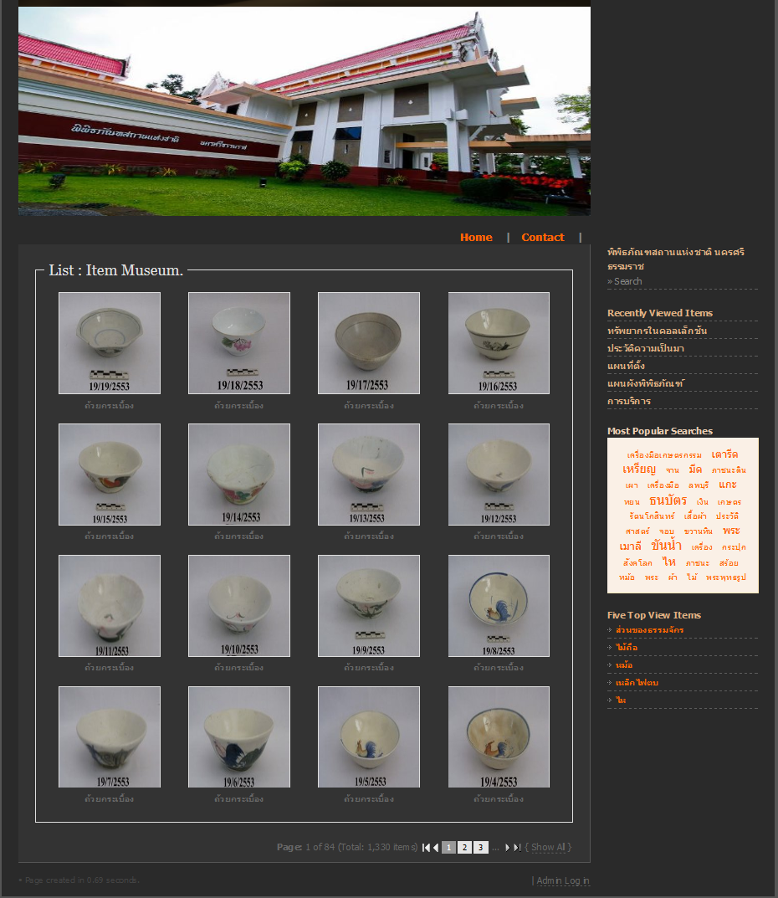
Fig. 1 Screenshot of the main page of the Nakhon Si Thammarat National Museum web site
On the main page (Fig. 1), it shows search, browse and social information access features at the right menu of this page.
One of the easy tool that let users take part and exchange their thoughts on an item is comments [14]. Users can fill in a comment text box on the particular item page. They can also read other comments and perhaps discuss about the item.

IV. Results

The objective of the study was to evaluate the initial user interface design of Nakhon Si Thammarat National Museum web site by using usability testing involved six tasks. The analysis based on data obtained through the questionnaire, interview, note-taking and think-aloud.
- Participant perception of Task success
After participants had finished each task, they were asked if they considered they had success in their performance of the task
For the first three tasks, all participants have the same answers. They thought this is museum web site. The target users might be researchers, teachers, students or people who have interested in History. Moreover, they belived that the web site provides relevant information to support them to complete their tasks.
For the last three tasks, the results found that only one participant couldn’t complete the final task within 3 minutes since she used only browse function by exploring all item pages without using search feature.
- Participants’ satisfaction
The participants were asked to rate the usability covering overall impression, information design interaction design, and interface design, from a five-point scale. Also, the participants were requested to rate overall of system, from a seven-point scale The statistical results as TABLE I and TABLE II, repectively.

As can be seen from TABLE I, for all statements, interaction
design was rated the best satisfied, followed by information design, respectively.

For all statements about overall of system, the organization of information was rated the best satisfied. Also, the participants seemed to appreciate ease of use of interface and satisfied with the terminology used of the system, as can be seen from TABLE II,

Finally, 5 participants were asked to answer opened-end questions (note that each participant can indicate more than one thing). The details are as follows.
TABLE II The median response to statements (overall of system) for interface (7 scale, higher=better)
Statements  (overall of system) | $$\overline{x}$$ | SD. | Level of participants’ satisfaction
The ease of use | 5.80 | 0.84 | Satisfied
The organization of information | 6.20 | 1.10 | Extremely satisfied
The terminology used | 5.80 | 1.30 | Satisfied
visually attractive | 4.20 | 2.28 | Undecided
Overall reaction | 4.80 | 1.30 | Somewhat satisfied
Average all above | 5.36 | 1.36 | Satisfied

For the best things of the interface, the results found that three participants liked well organization of materials including sufficient description and clear images of items. One participant liked “Most popular searches”, “Five top viewed items”, and “Recently viewed items” One participant liked search feature. Five participants liked an interesting topic and users’ comments, which is similar to a web board; they can exchange knowledge and ideas with each other. Also, one participant impressived in adequate information such as service of the museum and map etc.
TABLE I The median response to statements for interface (5 scale, higher=better)
Statements | $$\overline{x}$$ | SD. | Level of participants’ satisfaction
Overall impression | 3.76 | 0.97 | satisfied
Information Design | 4.20 | 0.80 | Very satisfied
Interaction Design | 4.24 | 0.64 | Very satisfied
Interface Design | 4.10 | 0.98 | satisfied
Average all above | 4.08 | 0.85 | Satisfied

For The worst things of the interface, the results showed that five participants commented that font size is too small; it is difficult to read. One participant commented that the interface should be improved for more attractive and aesthetic design in order to create an attractive look to users. The participant also suggested enhancing flash scripts or graphics to create animations. One participant commented that the theme of the site looks solemn and sacred. For search features, one participant commented that it should provide a search box to enter search terms on the top of the main page. it should not be necessary to click the search menu for opening a new page. Moreover, Two participants wanted 3D virtual environments and 3D museum items to be included in the museum web site.

V. Discussion

In this section, we discuss results of the usability study done in order to evaluate initial interface In order to measure task completion of the interface, We found that most participants performed tasks fairly well. They suggested that the font color, font size and display contents should be improved.
We found that most participants tend to use the search features for finding specific topics. This might assume that they may use this way to get the results they need quickly. Also, the results found that some participant were likely to use many features to complete the task such as browse, search and social information access features. (i.e. most popular searches).
We found that searching information might be the most usefulness feature, followed by browsing feature and social information access features. These results are in substantial agreement with those of T. Gross, D. Tan, and W. Wirsam [15] . CYCLADES system provides community support, search functions, collections and recommendations. He found that most users considered most functions very useful and useful. Providing a search text box on the menu in every page, avoiding clicking a back button in the browser and designing the main page fit to one screen are some of recommendations from participants that agree with C. Roda, A. Murphy Borel, E. Gentchev, and J. Thomas [16].

VI. Conclusion

The usability test help to understand participants’ interaction. Feedback from participants and recorded notes during test sessions provide a great insight into the strengths and weakness of initial interfaces. The numerous recommendations, such as changing font color and font size, re-formatting display information on pages and editing some confused terminology were used to improve and re-designed the user interface. Although the results indicate that participants tended to like the social information access features in the system, it seems not to be clear that the participants may benefit actually from the social information access features.
In the next phase of research, we used this findings to design better Nakhon Si Thammrat National Museum web site. We also conducted usability studies to investigate how participants perform different types of search tasks using the re-designed interface.

Acknowledgment

This research was supported by Coordinating Center for Thai Government Science and Technology Scholarship Students (CSTS) National Science and Technology Development Agency (NSTDA)

References

[1] S. H. Myaeng, and R. R. Korfhage. "Integration of user profiles: Models and experiments in information retrieval." Information processing & management 26.6, 1990, pp. 719-738.
[2] P. Hansen, A. M. Pejtersen, and H. Albrechtsen "Evaluation and Requirements Elicitation of a Dl Annotation System for Collaborative Information Sharing." Digital Libraries: Research and Development. Springer, 2007. pp. 177-86.
[3] M. S. Ackerman. Providing Social Interaction in the Digital Library. Proceedings of the First Annual Conference on the Theory and Practice of Digital Libraries. 1994.
[4] A. F. Smeaton, , and J. Callan. "Personalisation and Recommender Systems in Digital Libraries." International Journal on digital libraries 5.4, 2005, pp. 299-308.
[5] E. Kani‐Zabihi, G. Ghinea, S. Y. Chen. "Digital Libraries: What Do Users Want?" Online Information Review 30.4 , 2006, pp. 395-412.
[6] C. Shah. "Toward Collaborative Information Seeking (Cis)." arXiv preprint arXiv:0908.0709, 2009.
[7] V. L. O'Day, and R. Jeffries. Information Artisans: Patterns of Result Sharing by Information Searchers. Proceedings of the conference on Organizational computing systems. 1993. ACM.
[8] S. M. Ferreira, and D. N. Pithan,. "Usability of Digital Libraries: A Study Based on the Areas of Information Science and Human-Computer-Interaction." OCLC Systems & Services: International digital library perspectives 21.4, 2005, pp. 311-23.
[9] J. Rubin, D. Chisnell.Handbook of Usability Testing : How to Plan, Design, and Conduct Effective Tests. New York: Wiley, 1994.
[10] I Harms, and W. Schweibenz. "Evaluating the Usability of a Museum Web Site." 2001.
[11] J. Woo. "Usability Testing: Art Museum Web Sites." (2006). Web. 30 october 2015.
[12] J. Jeng. "What Is Usability in the Context of the Digital Library and How Can It Be Measured?" Information Technology And Libraries 24.2, 2005,pp. 47-56.
[13] J. Nielsen. "Why You Only Need to Test with 5 User." 2000. Web. 5 March 2010.
[14] C. Crumlish, and E. Malone. Designing Social Interfaces: Principles, Patterns, and Practices for Improving the User Experience. O'Reilly Media, 2009.
[15] T. Gross, D. Tan, and W. Wirsam. "Cyclades: An Environment for the Cooperative Management of Digital Information." Journal of Digital Information Management 3.2, 2005, pp. 146-52.
[16] C. Roda, A. Murphy Borel, E. Gentchev, and J. Thomas, "Digital image library development in academic environment: designing and testing usability", OCLC Systems & Services: International digital library perspectives, (2005) Vol. 21 Iss: 4, pp.264 – 284.

